ESP32-CC1101-Transmission
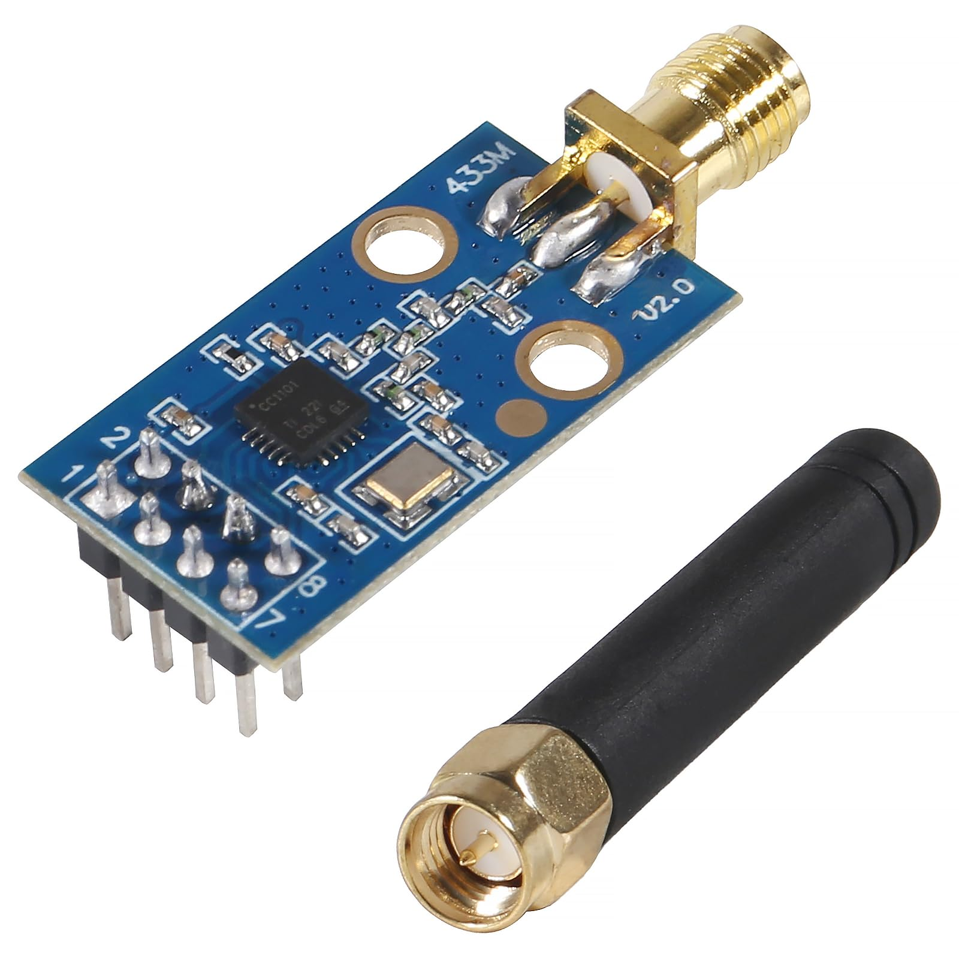

Introduction
This project's primary goal is to demonstrate how to transmit a signal using the CC1101 transceiver with the ESP-IDF framework. We will also explore how to interpret and navigate long technical datasheets, particularly those for RF devices. This guide is intended for readers who are looking to get started writing firmware for any embedded device.
Reading my previous writeup first will be very helpful when following this guide. In that writeup, I discuss the software and hardware prerequisites, as well as explain fundamental concepts about embedded devices. It also shows the more rudimentary task of reading a status register inside of the CC1101.
It is far more complex to transmit a radio signal with our device and the theory can be difficult to understand, so ensure you are comfortable with the topics in that guide before proceeding.
In addition to the steps outlined in my first guide, transmitting a signal with the CC1101 requires multiple stages:
- Setting the carrier frequency (i.e. 315 MHz)
- Configuring the modulation format (AM, FM, etc)
- Specifying the data rate
- Setting the power level of your radio
- Understanding how to format the data you want to transmit
- Transmitting that data in C++ with ESP-IDF
After explaining a few important concepts, we will go through exactly how to accomplish each of these steps with examples from the datasheet.
This README will heavily reference the official TI CC1101 transceiver datasheet as well as parts of the ESP32 documentation. This particular repository uses the PlatformIO IDE extension for VSCode, but using the ESP-IDF extension for VSCode is also viable.
Please see this project's guidelines for contributing & AI use.

Table of Contents
- Important Concepts
  - Carrier Frequency
  - Register Values
  - Radio States
  - Navigating the Datasheet
- Frequency Programming
  - Frequency Overview
  - Calculating the Frequency
- Modulation Format
  - Modulation Overview
  - Scientific Notation
  - Calculating the Frequency Deviation
- Bit Timing and Data Rate
  - Data Rate Overview
  - Calculating the Data Rate
- Transmit Power
  - Power Overview
  - Setting the Output Power
- Transmitting Packets
  - Packet Structure
  - Transmission Mechanics and the Data FIFO
  - TX FIFO Threshold
- Sending Data in C++
  - Configuring the SPI Bus
  - Helper Functions
  - Configuring Registers
- Running the Program
  - Proving the Transmission Was Successful
- Datasheet and Theory Abstraction in Libraries

1. Important Concepts

Carrier Frequency
The CC1101 uses what is known as a 'Carrier Frequency' to transmit data. The carrier frequency itself is just a sine wave, and properties of this wave are modulated to encode information. Common modulation techniques include FM and AM. FM (frequency modulation) works by shifting the frequency slightly while AM (amplitude modulation) works by varying the height of the wave to represent data.
Example: 2-FSK, which is a type of FM modulation, works by shifting between specific frequencies to represent bits. The amount the frequency shifts by is called the 'deviation.' If we are transmitting a 315 MHz signal, we might use a deviation of 25 kHz and send 314.975 MHz to signify a 0 bit and 315.025 MHz to signify a 1 bit.
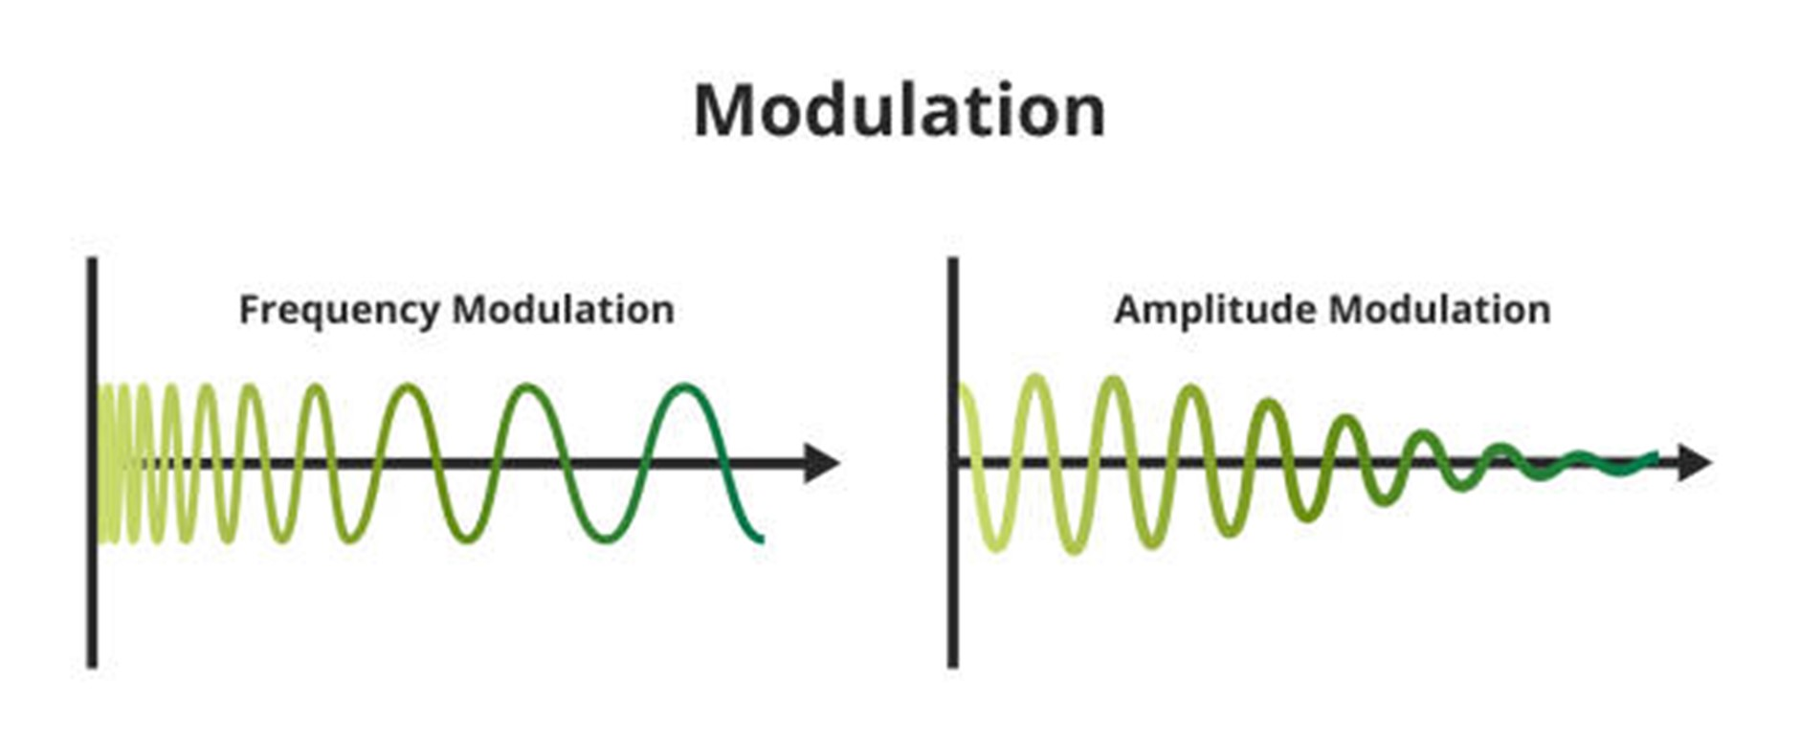
Visual Representation of AM and FM

Register Values
A 'register' inside of the CC1101 is an addressable location that contains a byte of data relating to configuration settings, status information, or command strobes. Some registers are dedicated to containing only a single field. One example of this is the RSSI register, which uses all 8 bits to hold the signal strength information.
Alternatively, some registers have unused bits or may contain multiple fields. In these cases, since multiple fields share the same register, we must modify only the relevant bits while leaving the others unchanged.
Using the FOCCFG register as an example, suppose we only want to set the FOC_PRE_K field to 11. The default bits in this register shown by the 'Reset' column are 0011 0110.
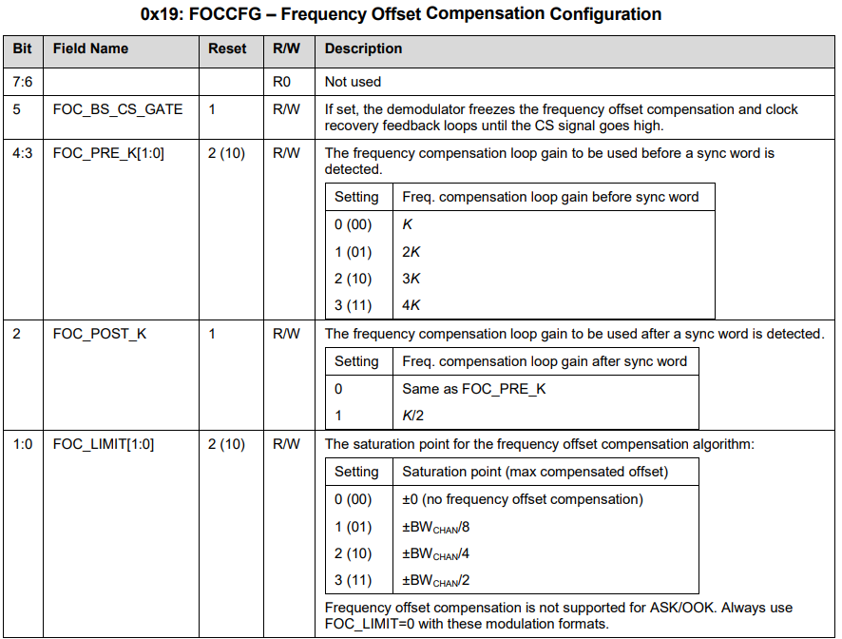
Page 83: FOCCFG Register
To preserve all other default values while updating the FOC_PRE_K field to 11, the resulting byte we send will be 0011 1110 (or 0x3E in hexadecimal). The table below shows the exact bit changes when we update this register.
Bits | Field | Default | New Value
7:6 | Not used | 00 | 00
5 | FOC_BS_CS_GATE | 1 | 1
4:3 | FOC_PRE_K[1:0] | 10 | 11
2 | FOC_POST_K | 1 | 1
1:0 | FOC_LIMIT[1:0] | 10 | 10
Note: An online binary to hex calculator can be helpful for converting register values.

Radio States
The concept of a 'radio state' in the CC1101 refers to the device's ability to exist and switch between different operational modes. Basically, the CC1101 can only perform specific actions like transmitting a signal if it is in the correct radio state.
Pictured below is the simplified Radio Control State diagram. It is not necessary to understand every part of the diagram, but it is helpful to understand the general concept. The full diagram can be found on page 50 of the datasheet.
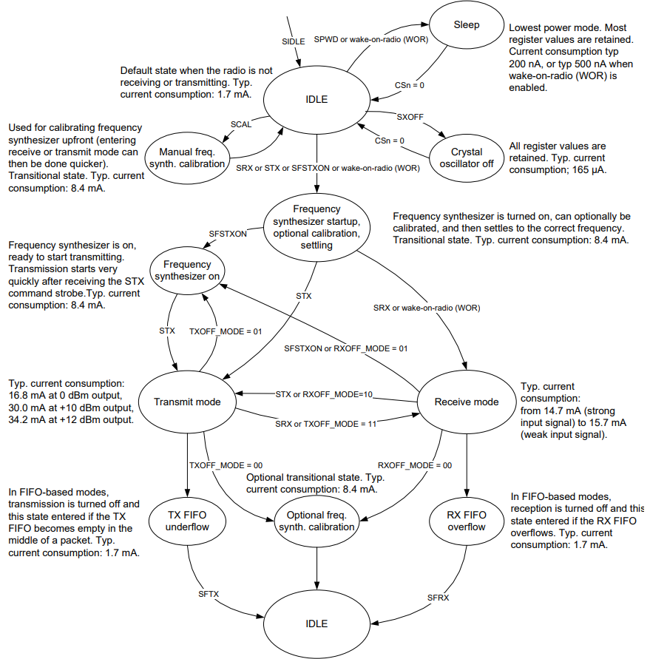
Page 28: Simplified Radio Control Diagram
Note
For example, the radio cannot enter the TXFIFO_UNDERFLOW state if it is in the IDLE state. It must first move through the required intermediate states like frequency synthesizer calibration and transmit mode.

Navigating the Datasheet
The CC1101 datasheet is around 100 pages long and contains many diagrams, equations, and tables detailing various properties of the device. If you have never worked with a datasheet before, it can be difficult to know where to begin. To approach this, we will work backwards from our goal of transmitting a signal with the CC1101 and think about what properties we need to configure in order to achieve this.
Section 8: Configuration Overview gives a holistic account of the radio's different functions and will be helpful in guiding our intuition. We can separate the datasheet sections into three different categories:
- The first category includes sections regarding general configuration. This includes how we can communicate with the CC1101, any specific power-on sequence the device requires, and other basic setup details.
- The second category includes sections regarding configuring the parameters of the signal we transmit. This includes the frequency, modulation technique, data rate, and radio power level.
- The third category includes sections that may be helpful for transmitting a signal, but are not strictly necessary. Any sections related to receiving signals will be ignored, since we are focusing solely on transmission.
With this mental map, let's analyze the datasheet and find the relevant sections. You will notice many of the earlier sections in the datasheet relate to the physical hardware specifications. This includes Section 1 (absolute maximum ratings), Section 2 (operating conditions), and so on. Many of these are not directly relevant to the goal of this project and can largely be ignored.
- Absolute Maximum Ratings
- Operating Conditions
- General Characteristics
- Electrical Specifications 4.1 Current Consumption 4.2 RF Receive Section 4.3 RF Transmit Section 4.4 Crystal Oscillator 4.5 Low Power RC Oscillator 4.6 Frequency Synthesizer Characteristics 4.7 Analog Temperature Sensor 4.8 DC Characteristics 4.9 Power-On Reset
- Pin Configuration
- Circuit Description
- Application Circuit 7.1 Bias Resistor 7.2 Balun and RF Matching 7.3 Crystal 7.4 Reference Signal 7.5 Additional Filtering 7.6 Power Supply Decoupling 7.7 Antenna Considerations 7.8 PCB Layout Recommendations
- Configuration Overview
- Configuration Software
- 4-Wire Serial Configuration and Data Interface 10.1 Chip Status Byte 10.2 Register Access 10.3 SPI Read 10.4 Command Strobes 10.5 FIFO Access 10.6 PATABLE Access
- Microcontroller Interface and Pin Configuration 11.1 Configuration Interface 11.2 General Control and Status Pins 11.3 Optional Radio Control Feature
- Data Rate Programming
- Receiver Channel Filter Bandwidth
- Demodulator, Symbol Synchronizer, and Data Decision 14.1 Frequency Offset Compensation 14.2 Bit Synchronization 14.3 Byte Synchronization
- Packet Handling Hardware Support 15.1 Data Whitening 15.2 Packet Format 15.3 Packet Filtering in Receive Mode 15.4 Packet Handling in Transmit Mode 15.5 Packet Handling in Receive Mode 15.6 Packet Handling in Firmware
- Modulation Formats 16.1 Frequency Shift Keying 16.2 Minimum Shift Keying 16.3 Amplitude Modulation
- Received Signal Qualifiers and Link Quality Information 17.1 Sync Word Qualifier 17.2 Preamble Quality Threshold (PQT) 17.3 RSSI 17.4 Carrier Sense (CS) 17.5 Clear Channel Assessment (CCA) 17.6 Link Quality Indicator (LQI)
- Forward Error Correction with Interleaving 18.1 Forward Error Correction (FEC) 18.2 Interleaving
- Radio Control 19.1 Power-On Start-Up Sequence 19.2 Crystal Control 19.3 Voltage Regulator Control 19.4 Active Modes (RX and TX) 19.5 Wake On Radio (WOR) 19.6 Timing 19.7 RX Termination Timer
- Data FIFO
- Frequency Programming
- VCO 22.1 VCO and PLL Self-Calibration
- Voltage Regulators
- Output Power Programming
- Shaping and PA Ramping
- General Purpose / Test Output Control Pins
- Asynchronous and Synchronous Serial Operation 27.1 Asynchronous Serial Operation 27.2 Synchronous Serial Operation
- System Considerations and Guidelines 28.1 SRD Regulations 28.2 Frequency Hopping and Multi-Channel Systems 28.3 Wideband Modulation When Not Using Spread Spectrum 28.4 Wireless M-Bus 28.5 Data Burst Transmissions 28.6 Continuous Transmissions 28.7 Battery Operated Systems 28.8 Increasing Range
- Configuration Registers 29.1 Registers Preserved in Sleep State 29.2 Registers That Lose Programming in Sleep State 29.3 Status Register Details
- Soldering Information
- Development Kit Ordering Information
- References
- General Information 33.1 Document History

General Configuration Sections
Whenever we are writing firmware for an embedded device, we need to know how to communicate with the system and if there are any peculiar setup details. My first writeup for the CC1101 described some of the sections about general configuration already, but we will briefly revisit them below.
- Section 10: 4-Wire Serial Configuration and Data Interface ~ This section tells us the protocol to use when communicating with the chip (SPI) and how to access registers in the CC1101. This is one of the first and most important sections to understand when writing firmware for this chip, as everything after this point builds off of this section.
- Section 29: Configuration Registers ~ Here we will find the addresses for all of the registers in the radio. These include status registers as well as configuration registers that hold our radio's signal parameters. Each section in the datasheet lists its relevant registers, so Section 29 will be referenced frequently.
- Section 19: Radio Control ~ Describes important setup details and how the radio operates internally through state transitions. Section 19.0 shows us the state control diagram, while Section 19.1 tells us the exact sequence the device expects when it powers on.

Signal Configuration Sections
Every radio transmission has specific parameters that must be configured, regardless of the device being used. These common parameters are the frequency, modulation type, data rate, and transmit power. Technically, the CC1101 has values for many of these in its registers by default, but they're not exactly useful if we want to transmit a custom signal. Therefore, we will configure these parameters manually.
Parameter | Purpose
Carrier frequency | Determines where in the RF spectrum we transmit
Modulation format | Determines how data is encoded onto the frequency
Data rate | Determines how fast bits are transmitted
Transmit power | Determines signal strength and range
- Section 21: Frequency Programming ~ Provides the relevant equations and registers for setting up the frequency the CC1101 will transmit at. You will also find information about setting up different frequency channels, where you can switch between multiple frequencies quickly (such as 315 MHz, 433 MHz, and 915 MHz).
- Section 16: Modulation Formats ~ Talks about the different types of modulation formats the CC1101 is capable of implementing.
- Section 12: Data Rate Programming ~ Discusses how to calculate and configure the data rate, which is how fast we send bits with our radio.
- Section 24: Output Power Programming ~ Details the relevant registers for setting the output power of the radio.
- Section 15: Packet Handling Hardware Support and Section 20: Data FIFO - These sections don't define explicit parameters about the signal, but rather how we will structure and send data with the signal.

Optional Sections
- Section 8: Configuration Overview ~ Description of different CC1101 parameters and capabilities.
- Section 9: Configuration Software ~ Suggestions on software to assist in calculating register values. This guide will not be using the recommended configuration software (SmartRF Studio); rather, we will be solving the datasheet equations by hand.
- Section 14: Demodulator, Symbol Synchronizer, and Data Decision - Offers context for how the CC1101 handles packets.
- Section 18: Forward Error Correction with Interleaving ~ Describes optional error correction techniques used to improve reliability during transmission. We will not be investigating this section in this guide.

2. Frequency Programming

Section 21: Frequency Programming Overview
Frequency programming in the CC1101 is a channel-oriented system. This means that you can store multiple frequencies inside registers and switch between them instantaneously. In this guide, we will only be configuring one frequency, so the parts in the datasheet regarding the MDMCFG0.CHANSPC_M, MDMCFG1.CHANSPC_E, FSCTRL1.FREQ_IF, and CHANNR.CHAN channel fields can be ignored for simplicity.
Note that parameters such as the frequency can only be changed while the radio is in the IDLE state.
The frequency is stored as a 24-bit word split across three registers containing 1 byte each: FREQ2, FREQ1, and FREQ0. Table 45 shows part of the CC1101's address space, where you can see the addresses of each frequency register (0x0D, 0x0E, and 0x0F respectively).
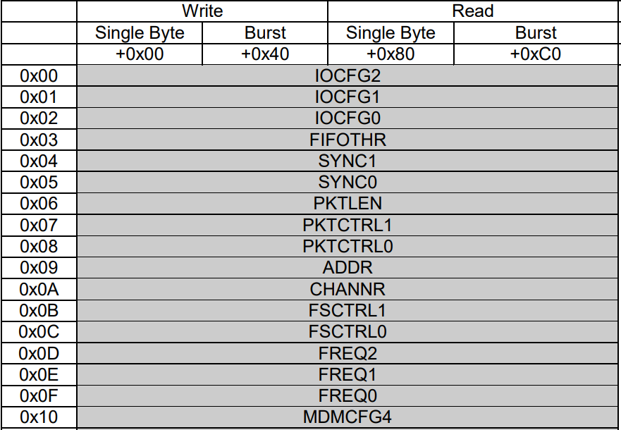
Table 45: SPI Address Space
Important
This 24 bit word is not representing a frequency such as 315 MHz. Rather, it is a value the CC1101 will use to derive the frequency using its equations. Also, a 'word' in this context simply means a collection of bits.

Calculating the Frequency
There are multiple equations in the frequency section. The equation regarding IF (intermediate frequencies) is only used for receiving signals. It converts the signal the radio receives into a lower frequency, as higher frequencies are more difficult to process. We do not have to solve for the equation below.
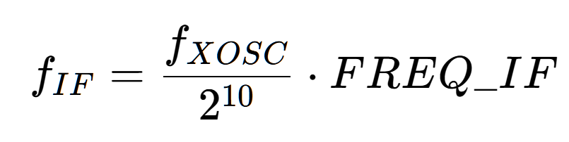
One thing to be aware of is a common variable found in many of the equations in the CC1101 data sheet, which is fxosc. This variable is referring to the rate at which the crystal oscillator vibrates. According to Section 4.4 of the data sheet, this value is between 26-27 MHz:
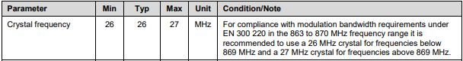

The main equation of importance to calculate our carrier frequency is the one below:
Where fcarrier is the desired transmit frequency (such as 315 MHz), fxosc is the rate at which the crystal oscillator vibrates (26 MHz), and FREQ is the value we need to program into the frequency registers discussed above. The other variables regarding channels such as CHAN and CHANSPC_M can be set to zero to simplify the equation (since we are not using any channel functionality on the CC1101). The resulting simplified equation is:
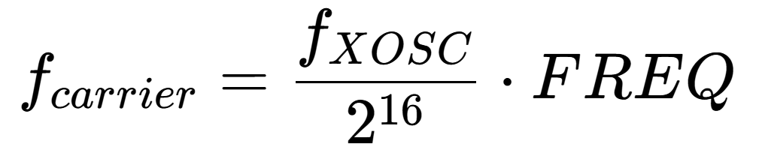
Assuming we want to transmit a signal at 315 MHz, we can substitute the values like so:
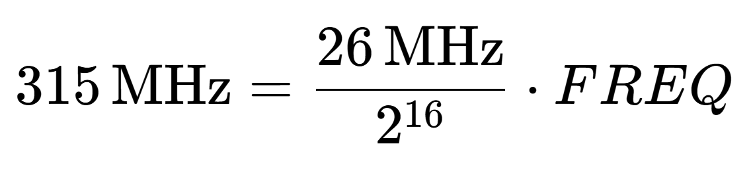
And rearrange the equation to solve for the frequency:
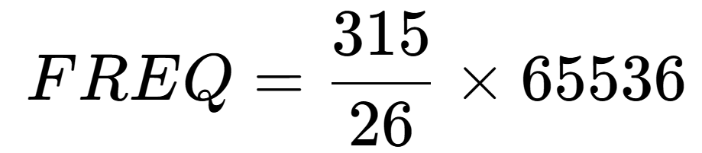
The result is FREQ ≈ 793,994.
The hard part of calculating the frequency is complete. Now all we have to do is store the value of FREQ across the three registers FREQ2, FREQ1, and FREQ0. 793,994 in hexadecimal is 0x0C1D8A. The reason we use three registers instead of one is, of course, the FREQ value is too large to store in a 1-byte register. We will send 0x0C to FREQ2, 0x1D to FREQ1, and 0x8A to FREQ0. The frequency registers are shown below.
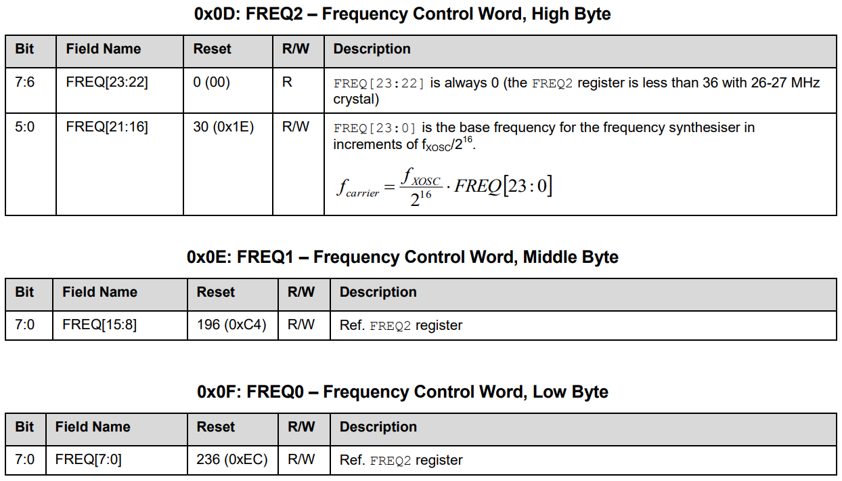
Page 75: Frequency Registers
Note: The upper two bits of FREQ2 are always set to 0 (not used). This is because the CC1101 is a sub-1 GHz transceiver. If we could hypothetically use all 24 bits and substitute that value into the carrier frequency equation, it might push the calculated frequency into the GHz range. This would be beyond the hardware capabilities of the CC1101.

Setting the Frequency in C++
Most of the coding examples will be shown in the Sending Data in C++ section of this guide. As a quick reference, we walk through setting the frequency before we move on to the next section of the guide.
We will use the value we calculated earlier of FREQ ≈ 793,994, which corresponds to setting the frequency to 315 MHz. Remember that communication with the CC1101 starts with a header byte following a specific format outlined in my first guide.
We must do the following to set the frequency:
- Construct the header byte.
  - Set bit position 7 of the byte to 0 to use write mode.
  - Set bit position 6 to 1 to denote burst access. This will let us write to all three frequency registers in one transaction.
  - Set bit positions 5–0 to 001101 for the FREQ2 register address. Since the address field is 6 bits wide, the original value of 1101 (0x0D) is padded with leading zeros.
  - The entire header byte is 01001101, or 0x4D.
- Convert 793,994 to hex which is 0x0C1D8A, and split this into three bytes; one for each register.
- Send the header byte, followed by the three bytes representing the FREQ value.
Note: When setting the burst bit to 1 in write mode, data is written sequentially to consecutive registers with increasing address values. This means we only need to specify the address of the first register for burst access. Refer to the register addresses listed below. The entire address list is visualized later in the guide.
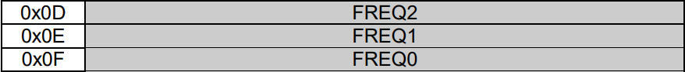
...
extern "C" void app_main(void) {
...
// The order that the registers will be written to is:
// FREQ2 -> FREQ1 -> FREQ0
// 0x0C goes to FREQ2, 0x1D to FREQ1, and 0x8A to FREQ0
spi_transaction(
cc1101, // Device handle
(uint8_t[]){0x4D, 0x0C, 0x1D, 0x8A}, // Bytes to transmit
4, // How many bytes we are transmitting
"FREQ" // Name of operation
);
}
Where spi_transaction is a helper function defined in main.cpp. After running this code, the radio will now be set to transmit at a frequency of 315 MHz.

Frequency Register Summary
Register | Register Address | Entire Updated Register Value | Purpose
FREQ2 | 0x0D | 0x0C | Frequency byte 2
FREQ1 | 0x0E | 0x1D | Frequency byte 1
FREQ0 | 0x0F | 0x8A | Frequency byte 0
Note: Each section will provide a summary of its relevant register values and locations. The full table can be found at the end of this guide.

3. Modulation Format

Section 16: Modulation Formats Overview
The CC1101 supports amplitude, frequency, and phase modulation formats. For this guide, we will be focusing on a type of frequency modulation known as 2-FSK (binary frequency shift keying). An example of how 2-FSK works in practice can be found in the Carrier Frequency section.
The register that stores the modulation format is named MDMCFG2. There is a table inside this register that shows we would need to send a value of 000 to the MOD_FORMAT field to specify 2-FSK as our format. The default value for this field is conveniently set to 000 already, so we technically don't need to worry about this register right now.
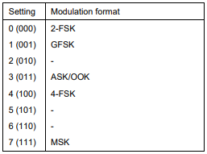
Page 77: Setting Table for the MDMCFG2.MOD_FORMAT Field at Address 0x12

Scientific Notation
2-FSK works by periodically shifting the frequency by an amount called the 'deviation.' The CC1101 uses two things to derive the value of the deviation: a mantissa and an exponent.
The mantissa allows for fine adjustment of the deviation, while the exponent scales the deviation value quickly. These concepts are also used in Scientific Notation. The mantissa and exponent values are configured in the DEVIATN.DEVIATION_M and DEVIATN.DEVIATION_E fields respectively at address 0x15.
Note
For example, 300 written in scientific notation is 3 * 102. 3 is the mantissa, and 2 is the exponent. We can see that changing the value of the exponent will cause a more drastic change in the result of this equation than changing the mantissa.
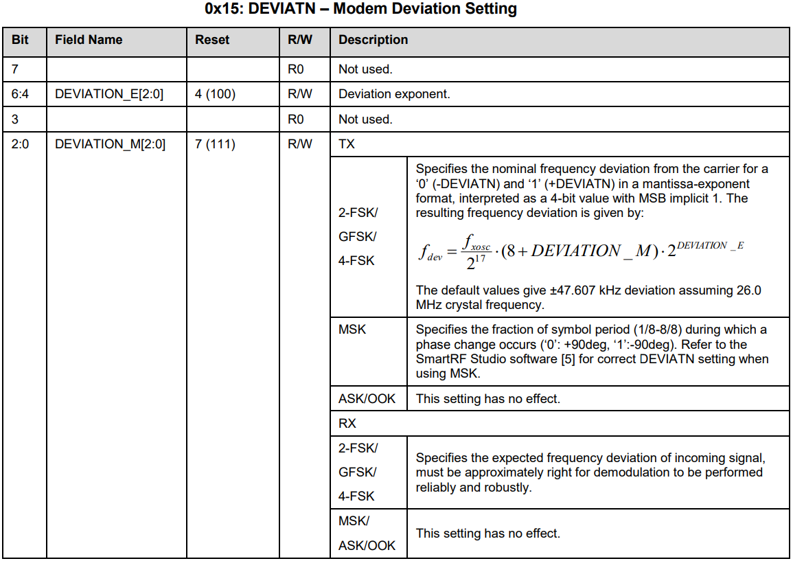
Page 79: DEVIATN Register

Calculating the Frequency Deviation
As mentioned before, we are implementing 2-FSK modulation which requires a value for the deviation. The deviation is given by the following equation:
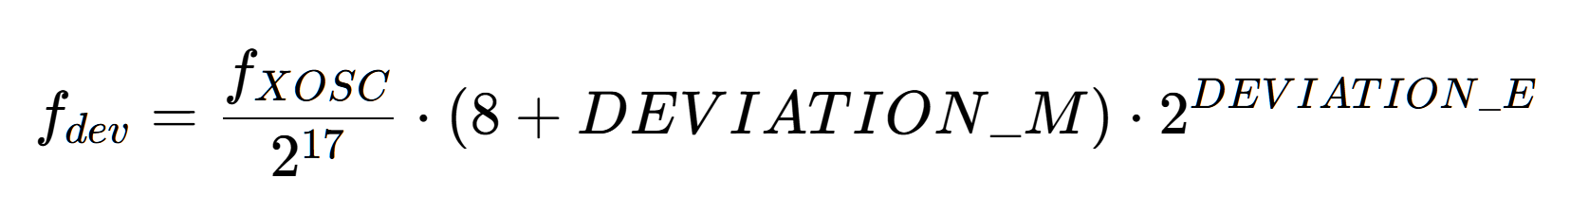
Where fxosc is the frequency of the crystal oscillator, DEVIATION_M is the mantissa, and DEVIATION_E is the exponent. The configuration software outlined in Section 9 of the datasheet can be used to generate mantissa and exponent values based off of a target deviation. Since we are solving the equation manually, we will instead have to examine how different mantissa and exponent values affect the resulting frequency deviation.
In practice, the frequency deviation and data rate values should be chosen together. To simplify this guide, we will instead pick a generally safe deviation of approximately 25 kHz. Relating the data rate to the frequency is called the modulation index. Further reading on 2-FSK is recommended if you want to optimize your values.
Since the DEVIATN register uses 3 bits for the exponent and 3 bits for the mantissa, each field can hold a value from 000 to 111. This means there are 8 different valid values for each part, leading to a total of 64 possible combinations between them.
I experimented with a few different values trying to get as close as possible to 25 kHz, and the best combination I came up with was DEVIATION_M = 0 and DEVIATION_E = 4. This gives us the equation:
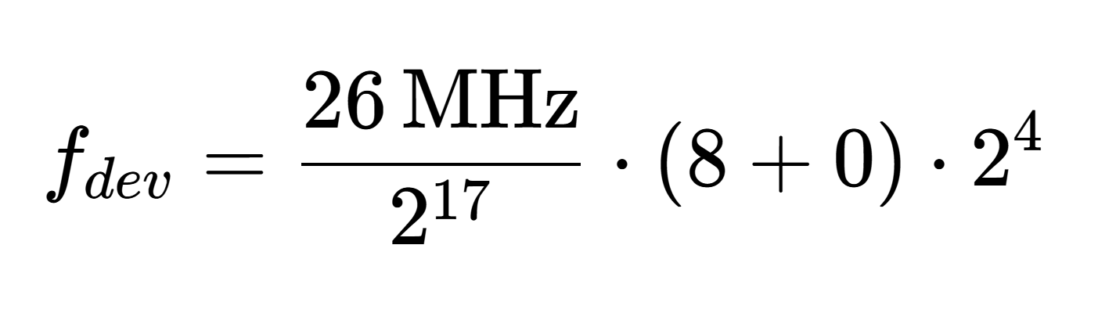
Solving this results in fdev = 25.4 kHz. Looking at the DEVIATN register at address 0x15, we can see that bit 7 and bit 3 are unused (set to 0), while bits 6-4 store the exponent and bits 2-0 store the mantissa. Using our exponent value of 4 and the mantissa value of 0, we end up with the binary number 0100 0000. Converting this value to hexadecimal gives us 0x40, which we will send to the register.

Modulation Register Summary
Register | Register Address | Entire Updated Register Value | Purpose
MDMCFG2.MOD_FORMAT | 0x12 | 0x00 | 2-FSK modulation format
DEVIATN.DEVIATION_E | 0x15 | 0x40 | Frequency deviation exponent
DEVIATN.DEVIATION_M | 0x15 | 0x40 | Frequency deviation mantissa
Note: The MDMCFG2 register can be set to 0x00 now, but it also contains another important field we will change later on in this guide. Additionally, the register values are identical for DEVIATN.DEVIATION_M and DEVIATN.DEVIATION_E because they share the same register, even though the field values themselves are different.

4. Bit Timing and Data Rate

Section 12: Data Rate Programming Overview
The data rate of the radio determines how fast data is transmitted or received. Similar to how we stored the deviation for 2-FSK modulation, we will store the mantissa and exponent calculated from the data rate equation into registers, rather than storing the literal data rate value.
The CC1101 will then use the mantissa & exponent values to derive the data rate in baud (which is a unit of transmission speed). The relevant fields for this section are MDMCFG3.DRATE_M and MDMCFG4.DRATE_E.
As stated previously, the data rate and frequency deviation should be related to one another through a modulation index. For this guide, we will instead simply use a safe baud rate of 25 kBaud.
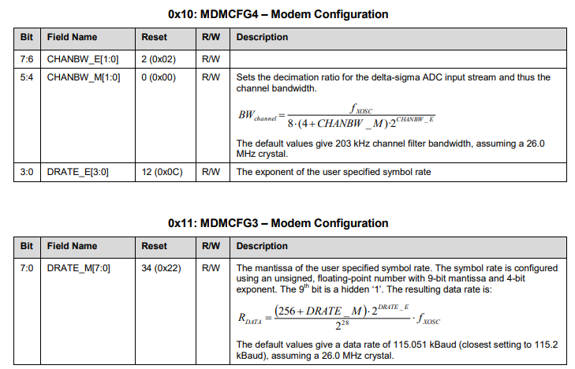
Page 76: Data Rate Registers

Calculating the Data Rate
There are a few important equations to consider when calculating the data rate. The variables in these equations are the data rate (RDATA), data rate mantissa (DRATE_M), data rate exponent (DRATE_E), and the crystal oscillator frequency (fxosc). The data rate formula the CC1101 uses internally is given below:
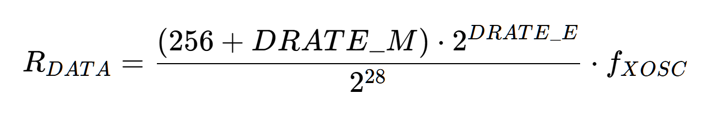
To find out the values of DRATE_E and DRATE_M, we must look at two other equations. The first of the two relates the data rate exponent to the crystal oscillator frequency and the data rate:
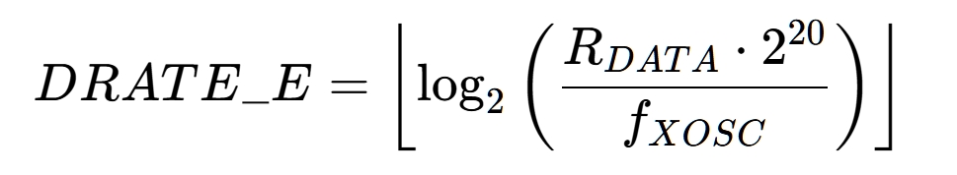
The second relates the data rate mantissa to the data rate, crystal oscillator frequency, and data rate exponent:
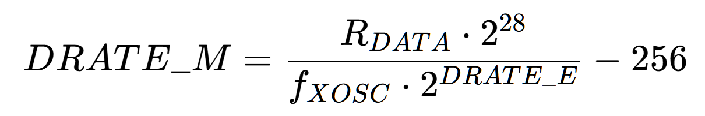
To determine these values, we first solve for DRATE_E, since its equation relates the target data rate to the crystal oscillator frequency. We know both of these values, as we decided earlier we want to target a data rate of 25 kBaud and our crystal oscillator's frequency is 26 MHz. With that said, our equation now becomes:
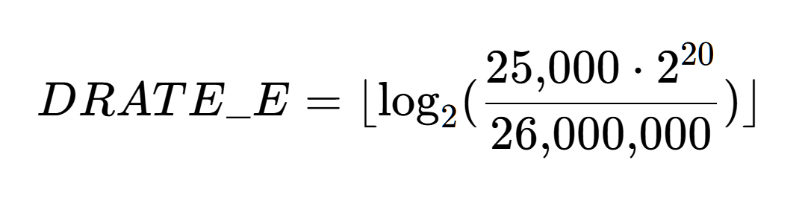
Solving this equation gives us DRATE_E = 9.
We now have all the appropriate values to substitute into the equation above that calculates the value of DRATE_M. Solving that equation gives us DRATE_M ​≈ 248.12. We will round this to the nearest integer which will be 248, as the register for the mantissa is only 8 bits. This means it can only store integers between 0-255, no decimals.
Since the data rate mantissa is the only field contained within the MDMCFG3 register, we do not have to worry about preserving any other bits. We will send our value of 248 here in hexadecimal which works out to be 0xF8.
We will store DRATE_E = 9 in the MDMCFG4 register, which also contains the fields used to configure channel bandwidth. It is good practice to preserve the default values in these registers if we don't need to modify them. Therefore, we will send the bits 10 for CHANBW_E, 00 for CHANBW_M, and 1001 for DRATE_E. We end up with 10001001 = 0x89.

Data Rate Register Summary
Register | Register Address | Entire Updated Register Value | Purpose
MDMCFG4.DRATE_E | 0x10 | 0x89 | Data rate exponent
MDMCFG3 | 0x11 | 0xF8 | Data rate mantissa

5. Transmit Power

Section 24: Output Power Programming Overview
The output power determines how strong the transmitted radio signal will be. The CC1101 stores up to 8 power amplifier settings in a special register called PATABLE. We will only be using one setting, so we can ignore the parts about the FREND0.PA_POWER field in the datasheet which would control selecting different power levels. We are going to program the first entry PATABLE[0], which is the default power setting used by the radio.
Below is a table showing what power output corresponds to what setting value. These settings vary depending on the frequency band being used, where a frequency band is simply a range of frequencies on the electromagnetic spectrum. We are going to look at the 315 MHz band column, as we want to transmit a 315 MHz signal for this project.
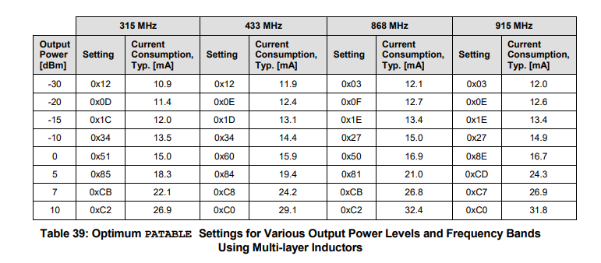
Note: There are tables for multi-layer inductors and wire-wound inductors in Section 24. The power output doesn't have to be a specific value for this project's goal, but just be aware that the power settings can change depending on what type of CC1101 module you have.

Setting the Output Power
The PATABLE register is located at address 0x3E. Since we are only setting a single power output, we will just be sending one byte to this address. Based on table 39, 0x51 provides a reasonable midrange transmit power for the 315 MHz band; we will send this value to the register. Section 10.6 provides more information on how to access the PATABLE register.

Output Power Register Summary
Register | Register Address | Entire Updated Register Value | Purpose
PATABLE[0] | 0x3E | 0x51 | Output transmit power

6. Transmitting Packets

Packet Structure
This guide uses the CC1101 packet handler (TX FIFO packet mode) to transmit data, not synchronous/asynchronous serial direct modes. For this mode, the packet structure in the CC1101 follows a particular pattern that is outlined in Section 15 of the datasheet.
In the figure below, we can see designated bits for things such as Preamble bits, the Sync Word, and the data field. This section of the guide will explain the anatomy of a packet and how to configure its different parts.
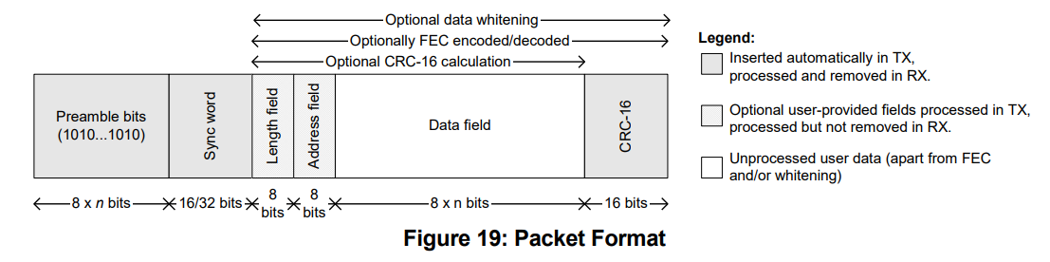

Preamble Bits
Preamble bits (or bytes) are a sequence of alternating bits sent at the start of a transmission that serve multiple purposes. The first is that they denote the beginning of a packet, letting the receiver know a transmission is starting.
The second purpose is that they assist in synchronizing the transmission timing between the receiver and the transmitter to ensure data is processed correctly. The overall purpose of the preamble bits is to help tune the receiver before meaningful data is sent.
In the CC1101, the amount of preamble bytes sent is configured in the MDMCFG1.NUM_PREAMBLE field at 0x13. The datasheet recommends using 4 bytes for the preamble (32 bits) which corresponds to setting 2 of the field.
When the radio enters TX mode, it will keep transmitting the preamble bytes you configured infinitely until a byte is written to the TX FIFO (we will go over what this looks like shortly).
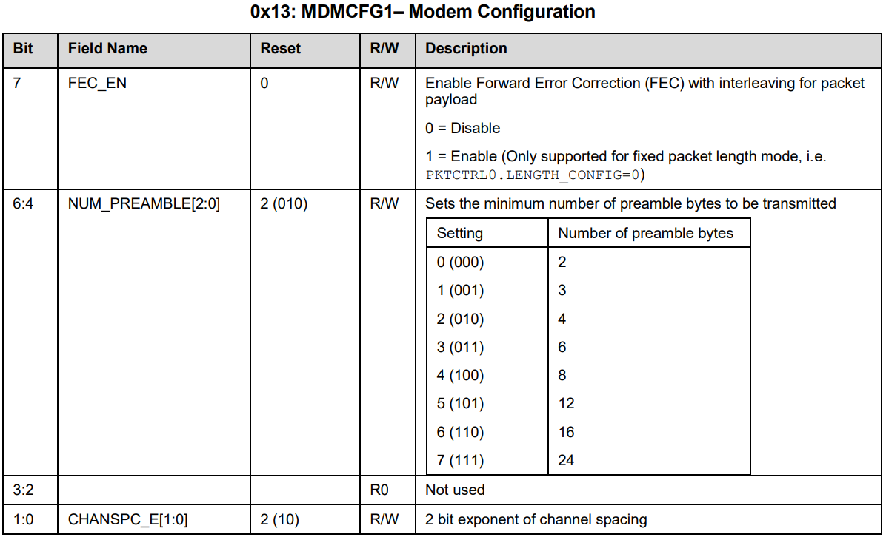
Page 77: MDMCFG1 Register

Synchronization Word
The Synchronization (sync) word's primary purpose is to mark the exact start of valid data in a signal. It can also help with network filtering, where a receiver can check the sync word of a signal and ignore signals that do not match the expected sync word.
More information on the sync word can be found in Section 14.3: Byte Synchronization. The sync word value itself is arbitrary, but the receiver and the transmitter must match each other if it is used.
The CC1101 recommends implementing a 4-byte sync word, stored in the SYNC1 and SYNC0 registers. Their addresses are 0x04 and 0x05 respectively. To reach the recommended 4 bytes in a sync word, we will have to send the MDMCFG2.SYNC_MODE field either a 3 (011) or a 7 (111). This will duplicate the 2 bytes we have stored in SYNC1 and SYNC0 and send 4 bytes in total when we transmit data.
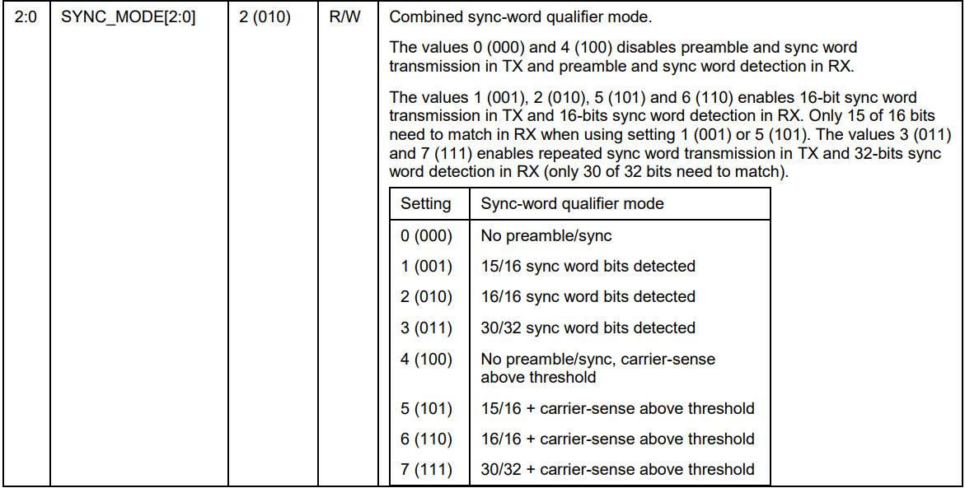
Page 77: MDMCFG2.SYNC_MODE Field
Note: If you have a sync word, you must always include preamble bits and vice versa. Both of these will be automatically inserted at the start of a transmission in setting 3 or 7. We will not have to manually send them after configuration.

Packet Length
The CC1101 expects a packet length mode to be configured in the PKTCTRL0.LENGTH_CONFIG field at 0x08. There are three different modes for packet length...
- Fixed packet length mode: the packet length is predefined and must be the same for every transmission. This length (in bytes) must be configured separately in the PKTLEN register at 0x06. This is the mode we will be using in our implementation later on.
- Variable packet length mode: the length of the packet is set by the first byte written to the TX FIFO instead of the PKTLEN register. Sequentially, this byte appears after the sync word.
- Infinite packet length mode: there is no set length of the packet, and the CC1101 will continually transmit data it is given.
Packet length settings do not include preamble bits or the sync word in the byte count.
Note: The maximum packet length for fixed and variable packet length modes is 255 bytes. Use infinite packet length mode for payloads longer than 255. Additionally, when working with packets that exceed the TX FIFO's capacity (64 bytes), consider Section 15.6: Packet Handling in Firmware.
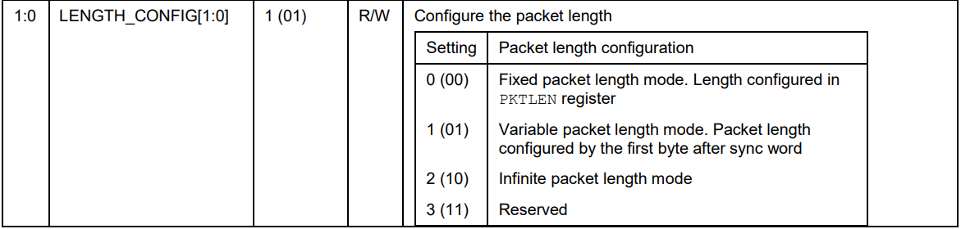
Page 78: PKTCTRL0.LENGTH_CONFIG Field

Other Packet Features
There are a few other optional packet features that we will not be implementing in this guide. These include:
- Data Whitening, which alters the bit pattern of transmitted data to help receivers decode it more effectively.
- Forward Error Correction and Interleaving, which helps receivers handle errors and makes the signal more robust.
- CRC (Cyclic Redundancy Check) Checksum, an error detection method that will let the receiver know if the packet is corrupted.
- The Address Byte, which is a byte dedicated towards address filtering. Similar to the sync word, this enables receivers to ignore irrelevant traffic and only look at signals with a specific address byte.

Packet Features Register Summary
Register | Register Address | Entire Updated Register Value | Purpose
MDMCFG1.NUM_PREAMBLE | 0x13 | 0x22 | 4-byte preamble
SYNC1 | 0x04 | 0xD3 | Sync word byte 1
SYNC0 | 0x05 | 0x91 | Sync word byte 0
MDMCFG2.SYNC_MODE | 0x12 | 0x03 | Repeated 2-byte sync word
PKTCTRL0.LENGTH_CONFIG | 0x08 | 0x00 | Fixed packet length mode
PKTLEN | 0x06 | 0x05 | 5-byte packet length

Transmission Mechanics and the Data FIFO

TX Radio State
As seen earlier in the simplified radio control diagram, the radio has a set number of states it can exist in. Each state can only be entered through specific transitions, including the state for transmit (TX) mode.
Every time the radio starts up, it should be reset with the SRES strobe and put into IDLE mode. To transmit data, we have to go from the IDLE state to the TX state. Luckily, we can reach this mode with a single command strobe called STX located at address 0x35.
There is one more aspect of the radio state that should be considered before transmitting a signal: calibrating the frequency synthesizer. We can enable automatic calibration when entering TX mode with the MCSM0.FS_AUTOCAL field at 0x18 by sending the byte 0x14. This will preserve the defaults while only changing the value of FS_AUTOCAL.
Shown below is the status register MARCSTATE that will contain the current state the radio is in, which is useful for debugging purposes.
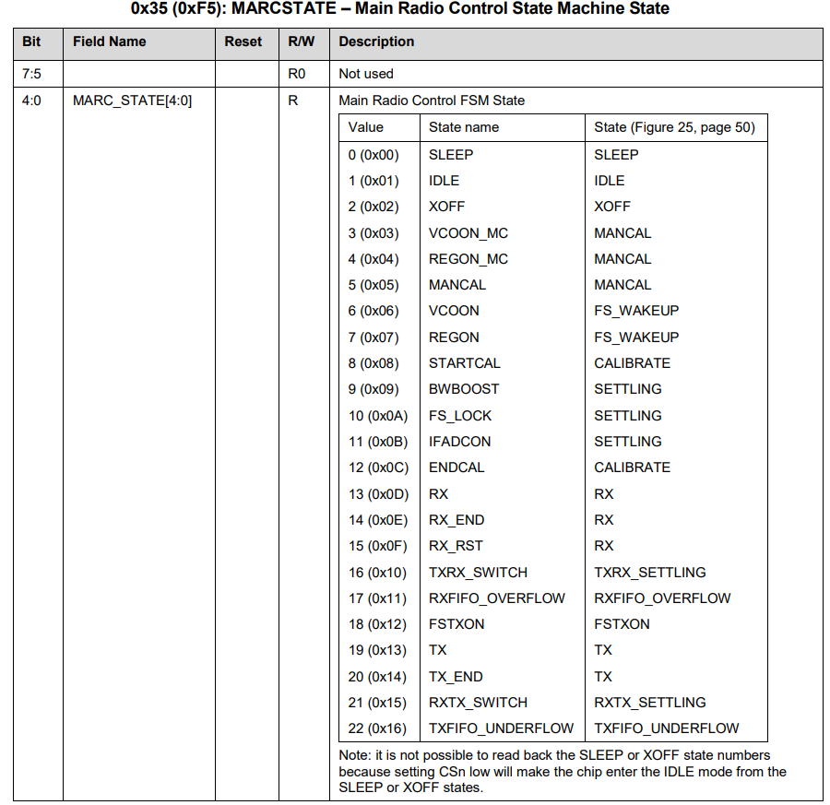
Page 93: MARCSTATE Register
Note: Both the STX command strobe and the MARCSTATE register are located at address 0x35. The difference is that when we communicate with the CC1101 using the SPI interface, we are changing the burst and R/W bit values to distinguish between a status register and a command strobe at the same address. Remember that an SPI transaction starts with a header byte that contains a R/W bit, a burst bit, and a 6-bit address. Setting the burst and R/W bit to 1 changes the header byte from 0x35 to 0xF5. Sending 0x35 activates the STX strobe, while sending 0xF5 returns the MARCSTATE register value. Refer back to the section regarding expected transaction format from my first guide.

Writing to the TX FIFO
The CC1101 contains two data FIFOs, one for transmitting data (the TX FIFO) and one for receiving data (the RX FIFO).
The TX/RX FIFOs are accessed through the address 0x3F. This area does not refer to a register, but rather to a data buffer. The TX FIFO is implemented as a 64-byte queue that sends data in the exact order it is fed; as data is transmitted, it leaves the buffer.
Below are the possible FIFO access header bytes from Section 10.5 and their respective functionalities. A R/W bit set to 0 corresponds to TX FIFO access, while a 1 corresponds to RX FIFO access.
- 0x3F: Single byte access to TX FIFO
- 0x7F: Burst access to TX FIFO
- 0xBF: Single byte access to RX FIFO
- 0xFF: Burst access to RX FIFO
For example, after sending the byte 0x7F, every subsequent byte sent in the same SPI transaction will be written into the TX FIFO.

Transmission Flow
Assuming there is data in the TX FIFO and preamble/sync word insertion is enabled in MDMCFG2.SYNC_MODE, let's look at the order of how CC1101 transmits data once it enters TX mode. Ignoring the optional packet features, the radio does the following:
- Automatically sends the programmed number of preamble bytes specified in the MDMCFG1.NUM_PREAMBLE field
- Attaches the sync word to the payload from SYNC1 and SYNC0
- Sends the data in the TX FIFO
During this flow, the radio can enter any of the scenarios outlined in the next section.
Note: Section 15.4 of the datasheet outlines the transmission flow.

TX Mode Scenarios
There are three different scenarios in TX mode that can occur either when writing to the TX FIFO or when a transmission finishes. These three scenarios are:
- The radio moves into the next state determined by the MCSM1.TXOFF_MODE field
- The radio enters the TXFIFO_UNDERFLOW state
- TX FIFO Overflow occurs

The first scenario is activated when a transmission is completed without any errors. In this case, the MCSM1.TXOFF_MODE field at address 0x17 will automatically put the radio into one of four states you can see in the image below.
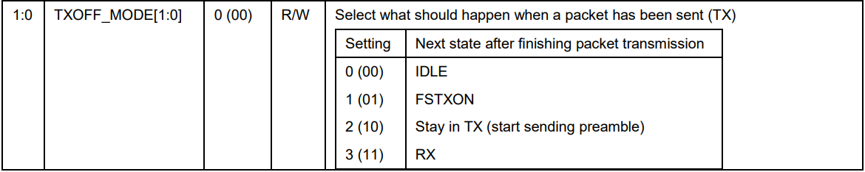
Page 81: MCSM1.TXOFF_MODE Field

The second scenario is entering the TXFIFO_UNDERFLOW state. This state occurs when the TX FIFO becomes empty in the middle of transmitting a packet. This error primarily happens when we specify a packet length, but the TX FIFO has less bytes than the number we configured.
For example, if we are in static packet length mode and send the PKTLEN register the value 0x0A, this will make our expected packet length 10 bytes. If we only fill our TX FIFO with 5 bytes and enter 'TX' mode, we will run out of bytes to send. In this scenario, the radio will enter the error state TXFIFO_UNDERFLOW.

The third scenario, TX FIFO Overflow, occurs when we fill the TX FIFO with more than 64 bytes of data. In this scenario, there isn't a specific state the radio enters like there is for underflow. Instead, the data in the FIFO might become corrupted and the radio may behave unpredictably.
Important
Suppose we set our packet length as 10 but fill the TX FIFO with 20 bytes. Upon completing a transmission, we may end up having leftover bytes sitting in the FIFO. This is not considered TX FIFO Overflow. Those bytes just remain there until they are emptied or sent in the next transmission.

Error Recovery
We must put the radio in a known safe state after we encounter an error such as TXFIFO_UNDERFLOW or TX FIFO Overflow. A common safe state to enter is the IDLE state. This helps the radio reset itself to a predictable baseline, which is why we immediately enter this state when we power on the device.
The command strobe to send for error recovery in TX mode is SFTX at address 0x3B. This will empty (flush) the TX FIFO and put the device in the IDLE state.
We can see what state the radio is in from either the MARCSTATE register or the chip status byte explained in Section 10.1. As seen in the image below, the chip status byte STATE field holds the state the radio is in, while the FIFO_BYTES_AVAILABLE field contains the number of bytes that can be written to the TX FIFO.
The meaning of this field changes if we are reading a register instead of writing to one.
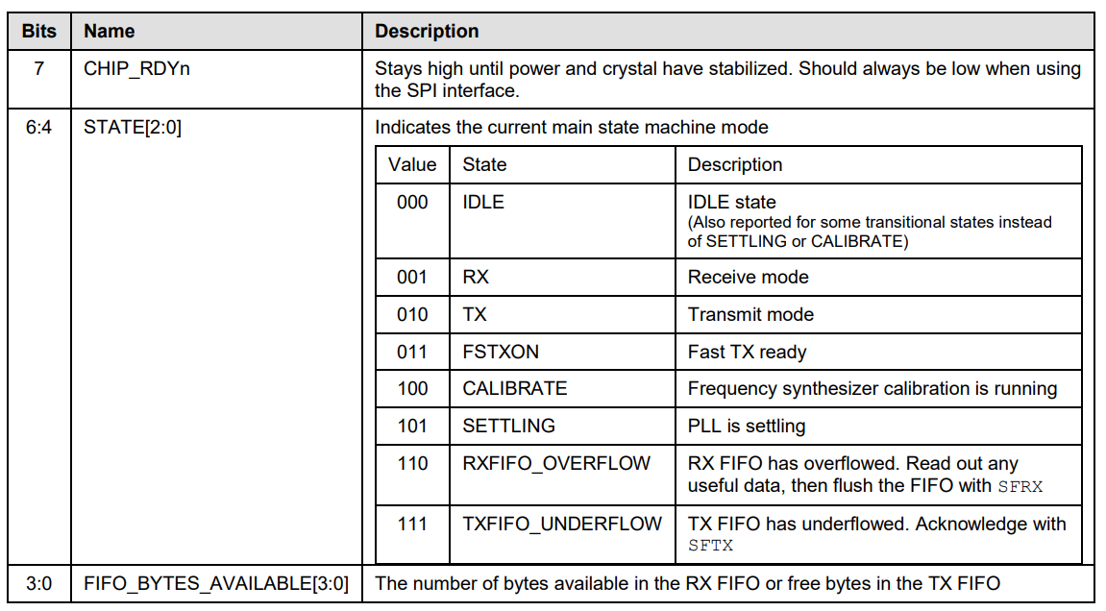
Page 31: Chip Status Byte Format
The maximum value of FIFO_BYTES_AVAILABLE is 15, or 1111. When FIFO_BYTES_AVAILABLE = 15, 15 or more bytes are available/free. To get the exact number of bytes in the TX FIFO, check the TXBYTES status register at address 0x3A. The header byte you should send to access this register is 0xFA (0x3A with the read and burst bits set).
Note: Recall that the chip status byte is always the first byte received back from the CC1101 in an SPI transaction.

TX FIFO Threshold
As stated earlier, the TX FIFO is a 64-byte buffer that holds the data you will transmit. Causing overflow or underflow in this buffer can cause error states and lead to unpredictable radio behavior. In addition to the chip status byte, there is another optional mechanism to assist us with managing the TX FIFO called the FIFO threshold.
In TX mode, the FIFO threshold is essentially a way to warn us when the number of bytes in the TX FIFO crosses a certain level. We can set the threshold by sending a value to the FIFOTHR.FIFO_THR register field at 0x03. Keep in mind this threshold is simply a warning, and does not prevent errors on its own.
For example, if we send the value 1110 to the register, we will get a warning when there is only 5 bytes left in the TX FIFO. The mapping of values to thresholds is seen below.
FIFO_THR Value | TX FIFO byte threshold
0000 | 61
0001 | 57
0010 | 53
0011 | 49
0100 | 45
0101 | 41
0110 | 37
0111 | 33
1000 | 29
1001 | 25
1010 | 21
1011 | 17
1100 | 13
1101 | 9
1110 | 5
1111 | 1
Page 56: FIFO Thresholds for TX Mode
The way we read this warning is different than how we read other data from the CC1101. The typical way we communicate with the CC1101 is through the SPI interface, where we send data from our ESP32 to the CC1101 through the MOSI pin and receive data from the CC1101 to our ESP32 with the MISO pin. For detecting the threshold warning, we instead use the GDO0 (general digital output) pin.
Reading the threshold is just a single use for the GDO0 pin. It can also let you know when the crystal oscillator is stable, when the chip enters the CHIP RDYn state, and much more. The GDO0 pin is configured in the IOCFG0.GDO0_CFG field at address 0x02. To set the GDO0 pin to warn us of the threshold, we coincidentally send the value 0x02 to this field.
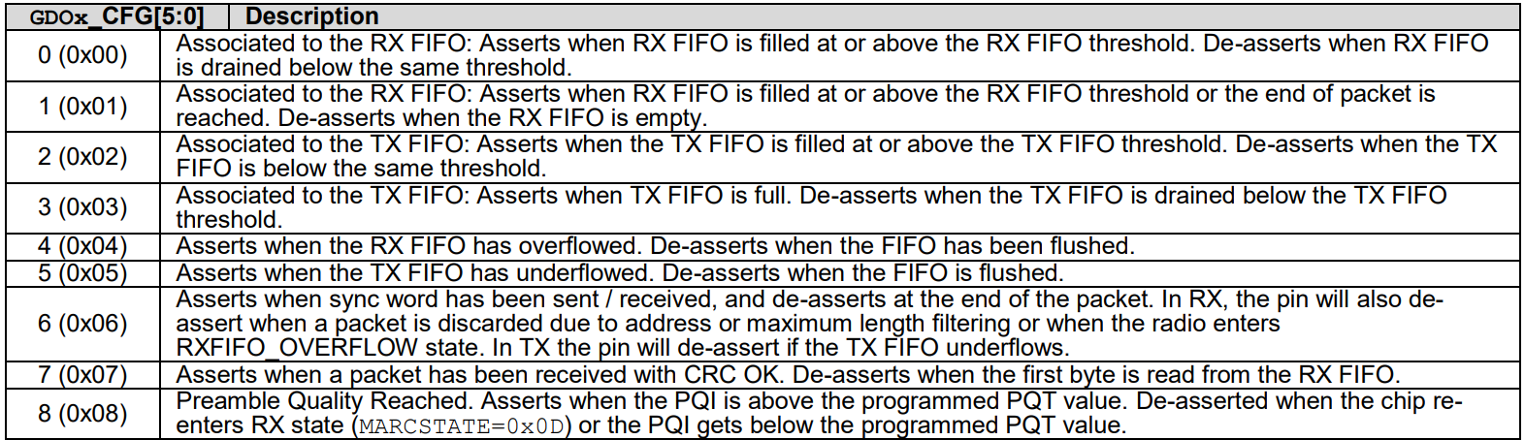
Page 62: The First 8 Configurations in the GDO_CFG Field
The GDO0 pin exists in a binary state of either being pulled high or low (we will read it as a 1 or a 0). It doesn't stream data like the MOSI/MISO pins. All it can do is act as a signal that answers yes or no to questions such as:
- Have we passed our TX FIFO threshold?
- Is the crystal oscillator stable?
- Has the TX FIFO underflowed?
Below is a representation of how the GDO0 pin acts when we set the transmit buffer to a certain value. We can see from the caption that the TX FIFO threshold is at setting 13 (1101), which corresponds to a threshold of 9 bytes. In TX mode, the pin goes high once we reach or surpass threshold, and is pulled low again when we drop below it.
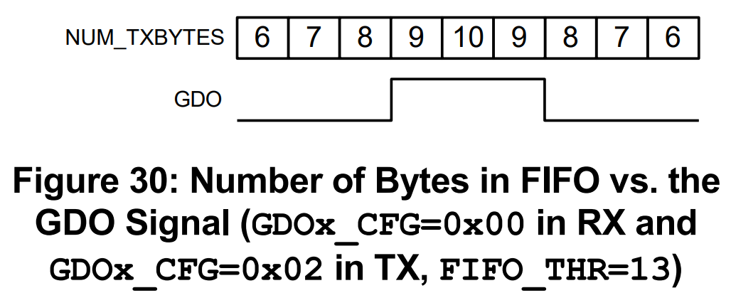
Page 56: FIFO Thresholds

Accessing the GDO0 Pin
We will use a standard GPIO pin on the ESP32 to access the CC1101's GDO0 pin. Every GPIO pin must be configured before it can be used. So prior to reading the GDO0 pin level, we must first configure the pin with the gpio_set_direction method from the ESP-IDF API. This method has two parameters:
- gpio_num: Which GPIO pin you are configuring. In our case, it will be the ESP32 pin GDO0 is connected to.
- mode: Sets if we can send or receive data on this pin.
We can read the GDO0 pin state with the gpio_get_level method. This method has one parameter:
- gpio_num: The GPIO pin you want to read the level of (high or low)
Assuming we configured the GDO0 pin in IOCFG0.GDO0_CFG to signal the TX FIFO threshold, the pin will return 1 when above the threshold and 0 when below it.
#include "driver/gpio.h"
#include "driver/spi_master.h"
#include "freertos/FreeRTOS.h"
extern "C" void app_main(void) {
...
// The mode that designates a pin
// as read-only is GPIO_MODE_INPUT
gpio_set_direction(GPIO_NUM_4, GPIO_MODE_INPUT);
...
gpio_get_level(GPIO_NUM_4); // Returns 1 or 0
...
}
Tip
Below is a reminder of the CC1101 pinout.
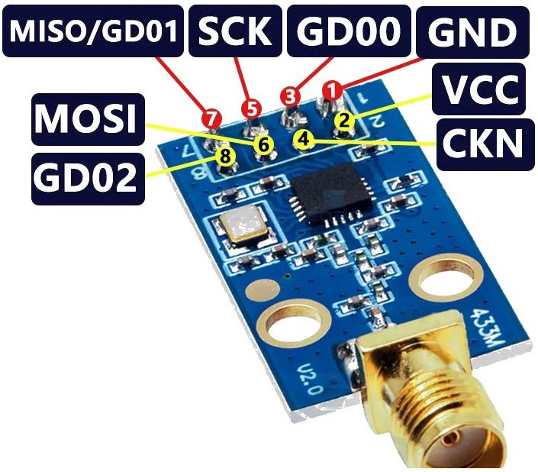

Transmission Mechanics Register Summary
Register | Register Address | Entire Updated Register Value | Purpose
MCSM0.FS_AUTOCAL | 0x18 | 0x14 | Auto-calibrate when entering TX mode
MCSM1.TXOFF_MODE | 0x17 | 0x31 | Enter FSTXON after TX completes
FIFOTHR.FIFO_THR | 0x03 | 0x0E | TX FIFO threshold set to 5 bytes
IOCFG0.GDO0_CFG | 0x02 | 0x02 | GDO0 signals TX FIFO threshold
TX FIFO | 0x3F | 0x01 x 7 | Payload bytes loaded for transmission

7. Sending Data in C++

Configuring the SPI Bus
To transmit a signal, the first thing our program must do is configure the SPI bus. Configuring the SPI bus takes the two methods spi_bus_initialize and spi_bus_add_device from the ESP-IDF API documentation. These methods were reviewed in depth in my first guide, so please refer back to those explanations if you want to know more.

Helper functions

spi_transaction
There are two important helper functions inside main.cpp that make accessing registers easier. The first function, spi_transaction, simplifies SPI transactions. To perform a transaction with this function, we simply pass in the device handle, an array of bytes to send, and the length of that array. This function is similar to the transmit_data function from the first guide.
void spi_transaction(spi_device_handle_t cc1101, const uint8_t* data, size_t len) {
spi_transaction_t t = {};
uint8_t rx[len];
t.tx_buffer = data;
t.rx_buffer = rx;
t.length = len * 8;
ESP_ERROR_CHECK(spi_device_polling_transmit(cc1101, &t));
}

Notes
- The tx_buffer is filled with the data we send, and the rx_buffer is filled with the response from the CC1101 which we can read off after the transaction.
- spi_device_polling_transmit is the function from the ESP-IDF API that performs the actual SPI transaction.
- rx_buffer[0] will always be the chip status byte.
- tx_buffer[0] will always be the header byte.

calculate_header_byte
The second function calculate_header_byte helps us calculate the header byte based off of how we want to interact with a register.
As previously mentioned, the header byte in an SPI transaction consists of a R/W bit, a burst bit, and a 6-bit address. If you are writing to a register without burst access (R/W bit = 0, burst bit = 0), the header byte will be the exact same as the register address.
If you are reading, using burst access, or both, the header byte changes by a fixed amount. We can use the bitwise OR operator on the register value to construct the final header byte to send.
Let's look at one example to demonstrate how this function works. Suppose you want to write to the register FREQ0, which has the address 0x0F (1111 in binary). The steps are as follows:

Pad the address to a full byte
0000 1111

Set the R/W bit (bit 7) and pad with 0's
For a read operation, the R/W bit is 1, which corresponds to:
1000 0000

Use the bitwise OR operation on the two bytes
0000 1111
1000 0000
---------
1000 1111
So, the final header byte we send becomes:
0x8F

Implementation
uint8_t calculate_header_byte(uint8_t reg, bool read, bool burst) {
return reg | (read ? 0x80 : 0x00) | (burst ? 0x40 : 0x00);
}
Where | is the C++ bitwise OR operator. This approach lets you store register addresses as constants and dynamically modify them depending on whether you are performing a read, write, or burst operation.

Configuring Registers
Configuring the registers is a very repetitive task. See the section Setting the Frequency in C++ for an example of what this looks like. One thing to note about configuring parameters in our program is that we are storing our register addresses in constants such as:
constexpr uint8_t CC1101_CONFIG_FREQ2 = 0x0D;
These constants are used to construct the final header byte with the calculate_header_byte function based on the burst and R/W bits.
For registers that are accessed in burst mode, we only send the first register's address in the transaction. Burst mode automatically increments the register address during the transaction, so we don't need to explicitly define the subsequent registers. The following registers are used but not explicitly defined as constants:
- FREQ1 and FREQ0, which come after FREQ2
- SYNC0, which comes after SYNC1
That is why you won't find a register address constant like CC1101_CONFIG_SYNC0 in the code (as it is accessed automatically through burst mode), but you will find CC1101_VALUE_SYNC0 because we still need to know what values to send to these addresses.
Note: Every single constant for register values defined in main.cpp has a comment explaining what their respective value means.

8. Running the Program
At this point, we have:
- Identified the registers required to transmit a signal
- Calculated the values required for a 315 MHz 2-FSK signal
- Learned the radio’s operating states and when to use command strobes
- Created helper functions in C++ to interact with the CC1101
The final step is to examine the program in main.cpp and analyze its output. We will see the constants defined at the top, then the helper functions, and finally the app_main function.
It is encouraged to skim the program and connect the ideas we have discussed so far in the guide to the implementation. If our devices are connected properly, we get the following output when we run the program:
I (297) main_task: Calling app_main()
I (1297) MAIN: Hello World...?
I (2297) CC1101: ========== ALL CONFIG VALUES ==========
I (2297) CC1101: Operation: READ AUTOCAL | 0x00 0x14
I (2297) CC1101: Operation: READ FREQUENCY | 0x00 0x0C 0x1D 0x8A
I (2297) CC1101: Operation: READ MOD FORMAT / SYNC MODE | 0x00 0x03
I (2307) CC1101: Operation: READ DEVIATION | 0x00 0x40
I (2307) CC1101: Operation: READ DATA RATE | 0x00 0x89 0xF8
I (2317) CC1101: Operation: READ POWER | 0x00 0x51
I (2317) CC1101: Operation: READ SYNC WORD | 0x00 0xD3 0x91
I (2327) CC1101: Operation: READ PREAMBLE | 0x00 0x22
I (2327) CC1101: Operation: READ PKTCTRL0 | 0x00 0x00
I (2337) CC1101: Operation: READ PKTLEN | 0x00 0x05
I (2337) CC1101: Operation: READ IOCFG0 | 0x00 0x02
I (2347) CC1101: Operation: READ FIFOTHR | 0x00 0x0E
I (2347) CC1101: Operation: READ MCSM1 | 0x00 0x31
I (2347) CC1101: Operation: READ MARCSTATE | 0x00 0x01
I (2357) CC1101: Operation: READ TXBYTES | 0x00 0x07
I (2357) CC1101: GDO0 level: 1
I (3367) CC1101: ============ AFTER 5 BYTES ============
I (3367) CC1101: Operation: READ MARCSTATE | 0x30 0x12
I (3367) CC1101: Operation: READ TXBYTES | 0x30 0x02
I (3367) CC1101: GDO0 level: 0
I (4367) CC1101: ============ AFTER 10 BYTES ===========
I (4367) CC1101: Operation: READ MARCSTATE | 0x70 0x16
I (4367) CC1101: Operation: READ TXBYTES | 0x70 0x80
I (4367) CC1101: GDO0 level: 0
I (4367) main_task: Returned from app_main()

Below is the first part of the log. This log is printed after we loaded 7 bytes into the TX FIFO and configured all of our registers. As the log states, these are all of our configuration values. I've attached comments to some of the logs below regarding their value or function...
I (2297) CC1101: ========== ALL CONFIG VALUES ==========
I (2297) CC1101: Operation: READ AUTOCAL | 0x00 0x14
I (2297) CC1101: Operation: READ FREQUENCY | 0x00 0x0C 0x1D 0x8A
I (2297) CC1101: Operation: READ MOD FORMAT / SYNC MODE | 0x00 0x03
I (2307) CC1101: Operation: READ DEVIATION | 0x00 0x40
I (2307) CC1101: Operation: READ DATA RATE | 0x00 0x89 0xF8
I (2317) CC1101: Operation: READ POWER | 0x00 0x51
I (2317) CC1101: Operation: READ SYNC WORD | 0x00 0xD3 0x91
I (2327) CC1101: Operation: READ PREAMBLE | 0x00 0x22
I (2327) CC1101: Operation: READ PKTCTRL0 | 0x00 0x00
// 5 byte packet length
I (2337) CC1101: Operation: READ PKTLEN | 0x00 0x05
// Set GDO0 to give alerts about TX FIFO threshold
I (2337) CC1101: Operation: READ IOCFG0 | 0x00 0x02
// Our TXFIFO Threshold is 5 bytes
I (2347) CC1101: Operation: READ FIFOTHR | 0x00 0x0E
// MCSM1 is the register for TXOFF_MODE. We set this field to 01, which essentially just means
// that the radio will enter the state FSTXON after a transmission is complete via the SFSTXON strobe. This is a state
// that performs some calibration steps that allows us to enter TX mode faster the next time
// we need to.
I (2347) CC1101: Operation: READ MCSM1 | 0x00 0x31
// This MARCSTATE value tells us the radio is in IDLE mode which is to be expected
I (2347) CC1101: Operation: READ MARCSTATE | 0x00 0x01
// We have loaded up 7 bytes into our TX FIFO at this point
I (2357) CC1101: Operation: READ TXBYTES | 0x00 0x07
// Our GDO0 pin reads high, telling us we have more than 5 bytes in our TX FIFO
I (2357) CC1101: GDO0 level: 1
All of the values logged above correspond to the values we came up with in the previous sections of this guide.

The next part of the log is printed after we enter TX mode which will automatically start sending preamble bits, the sync word, and a 5-byte packet. Upon a successful transmission completion, we should see the TXOFF_MODE register putting our radio into the FSTXON state.
I (3367) CC1101: ============ AFTER 5 BYTES ============
I (3367) CC1101: Operation: READ MARCSTATE | 0x30 0x12
I (3367) CC1101: Operation: READ TXBYTES | 0x30 0x02
I (3367) CC1101: GDO0 level: 0
As expected, our MARCSTATE register lets us know we are currently in the FSTXON state (corresponding to 0x12). We also see from the TXBYTES register that we have exactly 2 (0x02) bytes in our TX FIFO.
Since we only have 2 bytes left in our TX FIFO and our threshold is 5, Our GDO0 pin is now reading low.

The last thing we do is put our radio back into TX mode which will send another 5 bytes.
I (4367) CC1101: ============ AFTER 10 BYTES ===========
I (4367) CC1101: Operation: READ MARCSTATE | 0x70 0x16
I (4367) CC1101: Operation: READ TXBYTES | 0x70 0x80
I (4367) CC1101: GDO0 level: 0
Before attempting to send these 5 bytes, we only had 2 bytes in our TX FIFO. This means the radio will now enter the TXFIFO_UNDERFLOW state. We can confirm this since the chip status byte value is 0x70, the MARCSTATE register value is 0x16, and the TXBYTES register value is 0x80.

Proving the Transmission Was Successful
I've created a simple program that can receive radio signals using the Arduino framework with the RadioLib library to verify that our transmission worked. In that code, I matched all of the parameters configured in main.cpp, including frequency, bitrate, and modulation format.
Using 2 ESP32s and 2 CC1101s, I set up a working demo. One pair was flashed with the receiver code, and the other pair with the transmitter code.
The receiver logs the following data from the RX FIFO:
[CC1101] Waiting for 5-byte packet...
[CC1101] Timeout
[CC1101] Waiting for 5-byte packet...
[CC1101] Packet received
Data: D3 91 01 01 01
RSSI: -58.50 dBm // Strength of signal
LQI: 0 // Signal integrity
[CC1101] Waiting for 5-byte packet...
[CC1101] Packet received
Data: D3 91 01 01 DA
RSSI: -55.00 dBm
LQI: 26
The receiver code continuously polls the RX FIFO for incoming packets. Recall from main.cpp:
- The sync word was 32 bits (0xD3 and 0x91 repeated)
- The Packet length was 5 bytes
- The TX FIFO was filled with 7 bytes of 0x01
- We entered TX mode twice
The logs above generally reflect this scenario with a few issues.

The first issue is that the sync word (0xD3 0x91) shows up in the RX FIFO. This is unexpected since the sync word is handled internally, and the RX FIFO should only capture bytes from the packet's data field. This issue was likely caused due to RadioLib defaulting to a 16-bit sync mode, while our transmitter used 32 bits. Consequently, the receiver started filling the buffer two bytes too early.
Because of that misalignment, the first packet appears truncated. The full 5 bytes of 0x01 were still transmitted, but not all were printed out in the log. That leaves only two valid bytes out of the original 7 for the second transmission, which is expected.

The second issue is the actual bytes logged in the second transmission. It contains the 5 bytes D3 91 01 01 DA. The first two are the sync word, the next two are the remaining data from the TX FIFO, and the last byte is mysterious.
At first, I thought similar to how buffer underflow works in languages like C/C++, the radio might have underflowed and grabbed the last value from the register in the address space below the TX FIFO, which would be PATABLE.
This wouldn't make sense though, as there was no byte DA ever programmed into the PATABLE register. We will just have to dismiss this byte as random, nondeterministic noise sent when the TX FIFO underflowed.
To send and receive signals at the same time, I had to create a high tech setup on my basement floor...
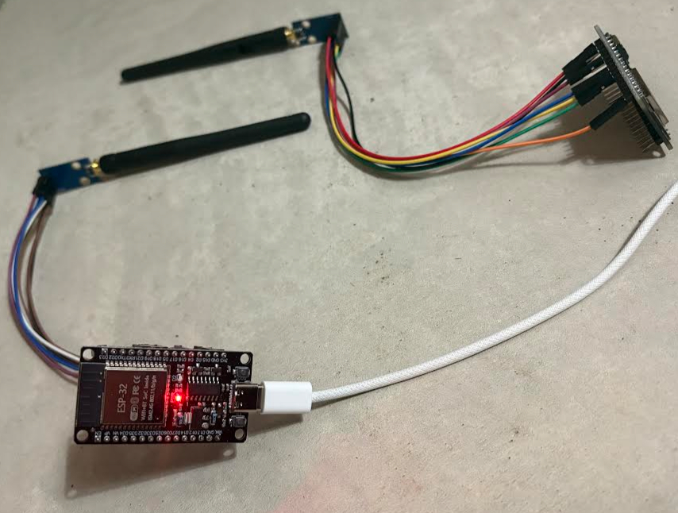

9. Datasheet and Theory Abstraction in Libraries
Transmitting a CC1101 signal with just the ESP-IDF framework necessitates a deep understanding of the datasheet as well as far more manual setup. Accomplishing the same goal with a framework requires minimal effort and little understanding of the theory.
One framework that can help us set everything up faster is the Arduino platform that gives us access to all of the ESP32 APIs. This, combined with a library specifically designed to communicate with the CC1101 such as RadioLib allows for the two devices to be used together without ever having to read the datasheet.

SPI Configuration Steps
The Arduino platform turns the SPI configuration code from the ESP-IDF:
spi_bus_config_t busConfig = {};
busConfig.mosi_io_num = GPIO_NUM_23;
busConfig.miso_io_num = GPIO_NUM_19;
busConfig.sclk_io_num = GPIO_NUM_18;
busConfig.quadwp_io_num = -1;
busConfig.quadhd_io_num = -1;
ESP_ERROR_CHECK(spi_bus_initialize(SPI3_HOST, &busConfig, SPI_DMA_DISABLED));
spi_device_interface_config_t deviceConfig = {};
spi_device_handle_t cc1101;
deviceConfig.command_bits = 0;
deviceConfig.address_bits = 0;
deviceConfig.dummy_bits = 0;
deviceConfig.mode = 0;
deviceConfig.clock_speed_hz = 1000000;
deviceConfig.spics_io_num = GPIO_NUM_5;
deviceConfig.queue_size = 1;
ESP_ERROR_CHECK(spi_bus_add_device(SPI3_HOST, &deviceConfig, &cc1101));
Into roughly the equivalent:
SPIClass radioSPI(VSPI);
radioSPI.begin(18, 19, 23, 5);
The code mapping of the two sections isn't exactly 1 to 1, but they essentially accomplish the same goal.
- SPIClass radioSPI(VSPI); selects the SPI host to use
- radioSPI.begin(18, 19, 23, 5); configures the pin mapping
Setting up lower level SPI parameters such as clock speed and SPI mode are handled internally by the libraries, so they typically don't need to be explicitly set here.

Register Configuration Steps
RadioLib turns the register values, configuration steps, and transmission steps from our original ESP-IDF code:
constexpr uint8_t CC1101_STROBE_SRES = 0x30;
constexpr uint8_t CC1101_STROBE_STX = 0x35;
constexpr uint8_t CC1101_STROBE_SIDLE = 0x36;
constexpr uint8_t CC1101_STROBE_SFTX = 0x3B;
constexpr uint8_t CC1101_CONFIG_FREQ2 = 0x0D;
constexpr uint8_t CC1101_CONFIG_MDMCFG2 = 0x12;
constexpr uint8_t CC1101_CONFIG_DEVIATN = 0x15;
constexpr uint8_t CC1101_CONFIG_MDMCFG4 = 0x10;
constexpr uint8_t CC1101_CONFIG_MDMCFG3 = 0x11;
constexpr uint8_t CC1101_CONFIG_PATABLE = 0x3E;
constexpr uint8_t CC1101_CONFIG_SYNC1 = 0x04;
constexpr uint8_t CC1101_CONFIG_MDMCFG1 = 0x13;
constexpr uint8_t CC1101_CONFIG_PKTCTRL0 = 0x08;
constexpr uint8_t CC1101_CONFIG_PKTLEN = 0x06;
constexpr uint8_t CC1101_CONFIG_IOCFG0 = 0x02;
constexpr uint8_t CC1101_CONFIG_FIFOTHR = 0x03;
constexpr uint8_t CC1101_CONFIG_MCSM1 = 0x17;
constexpr uint8_t CC1101_CONFIG_MCSM0 = 0x18;
constexpr uint8_t CC1101_STATUS_TXBYTES = 0x3A;
constexpr uint8_t CC1101_STATUS_MARCSTATE = 0x35;
constexpr uint8_t CC1101_REG_FIFO = 0x3F;
constexpr uint8_t CC1101_VALUE_FREQ2 = 0x0C;
constexpr uint8_t CC1101_VALUE_FREQ1 = 0x1D;
constexpr uint8_t CC1101_VALUE_FREQ0 = 0x8A;
constexpr uint8_t CC1101_VALUE_MDMCFG2 = 0x03;
constexpr uint8_t CC1101_VALUE_DEVIATN = 0x40;
constexpr uint8_t CC1101_VALUE_MDMCFG4 = 0x89;
constexpr uint8_t CC1101_VALUE_MDMCFG3 = 0xF8;
constexpr uint8_t CC1101_VALUE_PATABLE = 0x51;
constexpr uint8_t CC1101_VALUE_SYNC1 = 0xD3;
constexpr uint8_t CC1101_VALUE_SYNC0 = 0x91;
constexpr uint8_t CC1101_VALUE_MDMCFG1 = 0x22;
constexpr uint8_t CC1101_VALUE_PKTCTRL0 = 0x00;
constexpr uint8_t CC1101_VALUE_PKTLEN = 0x05;
constexpr uint8_t CC1101_VALUE_IOCFG0 = 0x02;
constexpr uint8_t CC1101_VALUE_FIFOTHR = 0x0E;
constexpr uint8_t CC1101_VALUE_MCSM1 = 0x31;
constexpr uint8_t CC1101_VALUE_MCSM0 = 0x14;
constexpr uint8_t CC1101_DUMMY_BYTE = 0x00;
uint8_t calculate_header_byte(uint8_t address, bool read, bool burst) {
return address | (read ? 0x80 : 0x00) | (burst ? 0x40 : 0x00);
}
void spi_transaction(spi_device_handle_t cc1101, const uint8_t* data, size_t len, const std::string& operation) {
spi_transaction_t t = {};
uint8_t rx[len];
t.tx_buffer = data;
t.rx_buffer = rx;
t.length = len * 8;
ESP_ERROR_CHECK(spi_device_polling_transmit(cc1101, &t));
};
void initialize_device(spi_device_handle_t cc1101) {
spi_transaction(cc1101, (uint8_t[]){CC1101_STROBE_SRES}, 1, "SRES");
spi_transaction(cc1101, (uint8_t[]){CC1101_STROBE_SIDLE}, 1, "SIDLE");
spi_transaction(cc1101, (uint8_t[]){CC1101_STROBE_SFTX}, 1, "SFTX");
};
extern "C" void app_main(void)
{
...
initialize_device(cc1101);
spi_transaction(cc1101, (uint8_t[]){calculate_header_byte(CC1101_CONFIG_MCSM0, false, false), CC1101_VALUE_MCSM0}, 2, "AUTOCAL");
spi_transaction(cc1101, (uint8_t[]){calculate_header_byte(CC1101_CONFIG_FREQ2, false, true), CC1101_VALUE_FREQ2, CC1101_VALUE_FREQ1, CC1101_VALUE_FREQ0}, 4, "FREQUENCY");
spi_transaction(cc1101, (uint8_t[]){calculate_header_byte(CC1101_CONFIG_MDMCFG2, false, false), CC1101_VALUE_MDMCFG2}, 2, "MOD FORMAT");
spi_transaction(cc1101, (uint8_t[]){calculate_header_byte(CC1101_CONFIG_DEVIATN, false, false), CC1101_VALUE_DEVIATN}, 2, "MOD DEVIATION");
spi_transaction(cc1101, (uint8_t[]){calculate_header_byte(CC1101_CONFIG_MDMCFG4, false, true), CC1101_VALUE_MDMCFG4, CC1101_VALUE_MDMCFG3}, 3, "DATA RATE");
spi_transaction(cc1101, (uint8_t[]){calculate_header_byte(CC1101_CONFIG_PATABLE, false, false), CC1101_VALUE_PATABLE}, 2, "POWER");
spi_transaction(cc1101, (uint8_t[]){calculate_header_byte(CC1101_CONFIG_SYNC1, false, true), CC1101_VALUE_SYNC1, CC1101_VALUE_SYNC0}, 3, "SYNC WORD");
spi_transaction(cc1101, (uint8_t[]){calculate_header_byte(CC1101_CONFIG_MDMCFG1, false, false), CC1101_VALUE_MDMCFG1}, 2, "PREAMBLE");
spi_transaction(cc1101, (uint8_t[]){calculate_header_byte(CC1101_CONFIG_MDMCFG2, false, false), CC1101_VALUE_MDMCFG2}, 2, "SYNC MODE");
spi_transaction(cc1101, (uint8_t[]){calculate_header_byte(CC1101_CONFIG_PKTCTRL0, false, false), CC1101_VALUE_PKTCTRL0}, 2, "PKTCTRL0");
spi_transaction(cc1101, (uint8_t[]){calculate_header_byte(CC1101_CONFIG_PKTLEN, false, false), CC1101_VALUE_PKTLEN}, 2, "PKTLEN");
spi_transaction(cc1101, (uint8_t[]){calculate_header_byte(CC1101_CONFIG_MCSM1, false, false), CC1101_VALUE_MCSM1}, 2, "TXOFF MODE");
spi_transaction(cc1101, (uint8_t[]){calculate_header_byte(CC1101_REG_FIFO, false, true), 0x01, 0x01, 0x01, 0x01, 0x01, 0x01, 0x01}, 8, "TX FIFO");
spi_transaction(cc1101, (uint8_t[]){calculate_header_byte(CC1101_CONFIG_IOCFG0, false, false), CC1101_VALUE_IOCFG0}, 2, "GDO0 CONFIG");
spi_transaction(cc1101, (uint8_t[]){calculate_header_byte(CC1101_CONFIG_FIFOTHR, false, false), CC1101_VALUE_FIFOTHR}, 2, "FIFO THR");
spi_transaction(cc1101, (uint8_t[]){CC1101_STROBE_STX}, 1, "TX MODE");
...
}
Into (approximately) just this:
CC1101 radio = new Module(5, 4, RADIOLIB_NC, RADIOLIB_NC, radioSPI);
int state;
state = radio.begin(315.0, 25.0, 25.0, 58.0, 0, 4);
state = radio.setSyncWord(0xD3, 0x91);
state = radio.fixedPacketLengthMode(5);
state = radio.transmit((uint8_t[]){0x01, 0x01, 0x01, 0x01, 0x01}, 5);
A few of the values we explicitly set in our original program were redundant, as the CC1101 has certain default register values that were already aligned with our guide's goals. Even when considering that, our original code is still far larger than the relatively equivalent Arduino code. Not to mention all the time needed for navigating and understanding the datasheet.
This is the classic abstraction tradeoff... the ease and speed of development with libraries vs the customization and performance without them. Most hobbyist projects will benefit from using a library, unless a deeper understanding of the hardware is sought out.

This will be the end of this series on investigating the CC1101. If you would like to ask any questions or discuss embedded devices in general, feel free to reach out on LinkedIn!
If you would like to contribute, please see the contributions guide inside of this repository.

Other Media

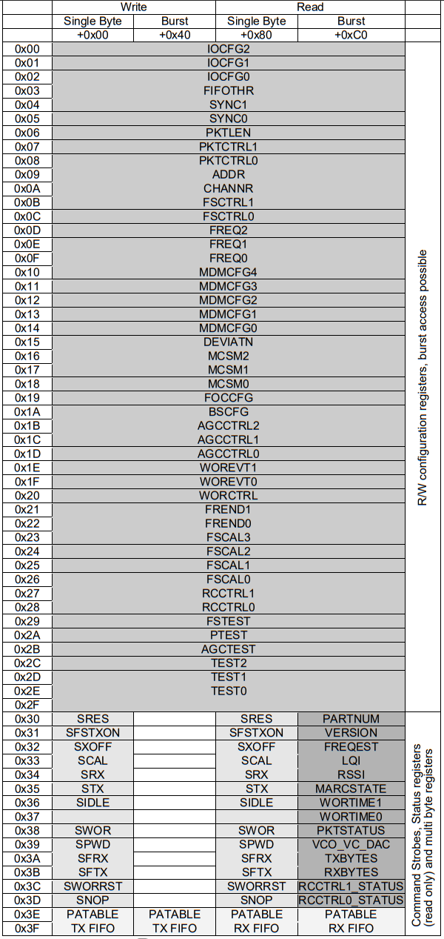
Table 45: Entire SPI Address Space

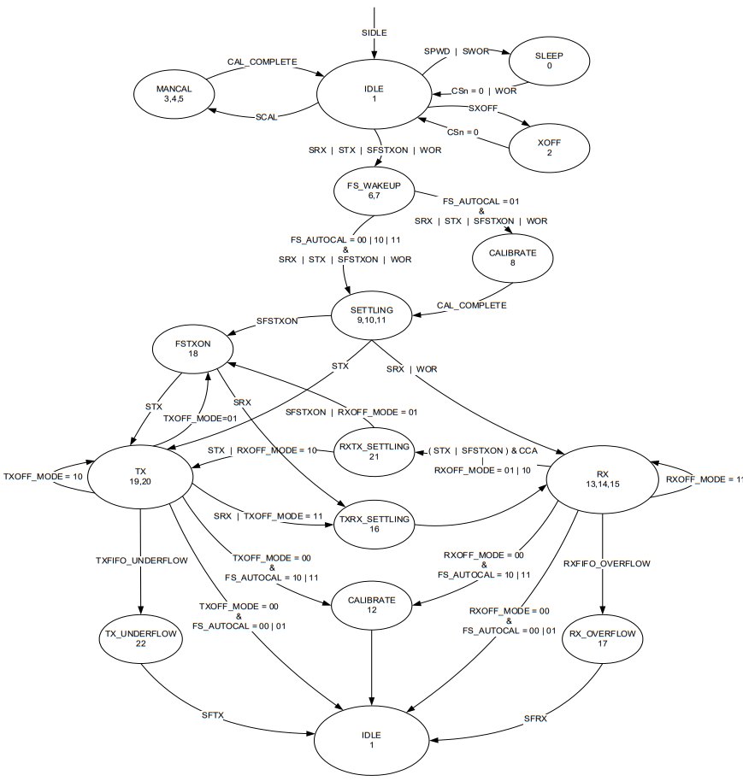
Figure 25: Complete Radio Control State Diagram

Register | Register Address | Entire Updated Register Value | Purpose
FREQ2 | 0x0D | 0x0C | Frequency byte 2
FREQ1 | 0x0E | 0x1D | Frequency byte 1
FREQ0 | 0x0F | 0x8A | Frequency byte 0
MDMCFG2.MOD_FORMAT | 0x12 | 0x00 | 2-FSK modulation format (value to be changed later by sync mode field)
DEVIATN.DEVIATION_E | 0x15 | 0x40 | Frequency deviation exponent
DEVIATN.DEVIATION_M | 0x15 | 0x40 | Frequency deviation mantissa
MDMCFG4.DRATE_E | 0x10 | 0x89 | Data rate exponent
MDMCFG3 | 0x11 | 0xF8 | Data rate mantissa
PATABLE[0] | 0x3E | 0x51 | Output transmit power
MDMCFG1.NUM_PREAMBLE | 0x13 | 0x22 | 4-byte preamble
SYNC1 | 0x04 | 0xD3 | Sync word byte 1
SYNC0 | 0x05 | 0x91 | Sync word byte 0
MDMCFG2.SYNC_MODE | 0x12 | 0x03 | Repeated 2-byte sync word
PKTCTRL0.LENGTH_CONFIG | 0x08 | 0x00 | Fixed packet length mode
PKTLEN | 0x06 | 0x05 | 5-byte packet length
MCSM0.FS_AUTOCAL | 0x18 | 0x14 | Auto-calibrate when entering TX mode
MCSM1.TXOFF_MODE | 0x17 | 0x31 | Enter FSTXON after TX completes
FIFOTHR.FIFO_THR | 0x03 | 0x0E | TX FIFO threshold set to 5 bytes
IOCFG0.GDO0_CFG | 0x02 | 0x02 | GDO0 signals TX FIFO threshold
TX FIFO | 0x3F | 0x01 x 7 | Payload bytes loaded for transmission
All Relevant Register Values, Addresses, and Purposes

